

TEST REPORT

Doc No: HTPL/FOR/ENGG/TR08
Ver: 1.2

DOCUMENT DETAILS

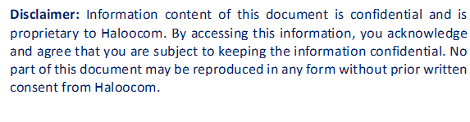

HTPL/FOR/ENGG/TR08
SOFTWARE TEST REPORT

OVERVIEW
Testing was completed by Sauravi and Mehul on August 11, 2025. Enhancement was implemented and verified for MSwipe Hexa to create a chart legend for H/M/L (High/Medium/Low) scoring in dashboard upgrades for Propensity Score visualization.
The objective was to implement and verify the client request for MSwipe Hexa to:
- Create interactive chart legend for Propensity Score visualization
- Display H/M/L (High/Medium/Low) scoring categories with clear visual indicators
- Implement dashboard upgrades with enhanced user experience for score interpretation
- Ensure proper legend positioning and responsiveness across different screen sizes

SOFTWARE IDENTIFICATION
- Name: Call Centre Software.
- Module Name: Dashboard Module (Propensity Score Charts)
- Version: 1.2

TEST DATES & DURATION
- Test Start Date: August 11, 2025
- Test Completion Date: August 11, 2025
- Test Duration: 1 day
- Test Effort: 2 person-days

TEST RESOURCES
People Involved
- Test Lead: Sauravi
- Test Analyst: Mehul
- Development Lead: Nagendra
- Developer: Sauravi

ISSUES RAISED
Bug ID | Description | Severity | Status
BUG_001 | Legend color codes inconsistent with main chart colors. | Medium | Open

BUGS FIXED
Bug ID | Description | Fix Details | Status
BUG_001 |  | Updated legend component to reference the same color palette constants as the main chart rendering engine. | ✅ Fixed
  Legend color codes inconsistent with main chart colors.

ADDITIONAL DETAILS
What Was Tested
- Chart legend creation and positioning in dashboard.
- H/M/L scoring category visualization with proper color mapping.
- Responsive design across desktop, tablet, and mobile devices.
- Legend interactivity (hover effects, click-to-filter functionality).
- Integration with existing Propensity Score charts.
- Cross-browser compatibility testing.
Summary
- Issue Identified: Minor display and color consistency issues.
- Severity: Medium.
- Status: Resolved
Workaround
- NA (Fixed in code directly)
Recommendation
Implement additional dashboard enhancements including:
- Add export functionality for charts with legend.
- Consider implementing chart animation when legend filters are applied.
- Add tooltips with detailed propensity score ranges for each category.
- Implement user preference settings for legend position.
- Consider adding a compact legend mode for smaller screens.

APPROVALS
Approver | Signature | Date

