

TEST REPORT

Doc No: HTPL/FOR/ENGG/TR01
Ver: 1.2

DOCUMENT DETAILS

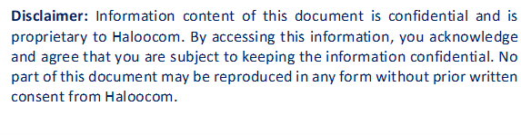

HTPL/FOR/ENGG/TR01
SOFTWARE TEST REPORT

OVERVIEW
Testing was completed by Sauravi and Mehul on June 12, 2025. Multiple issues were identified during the testing of the date-range filter functionality:
The objective was to implement and verify the date-range filter-based dashboard feature for Mswipe Hexa, where users needed to filter dashboard data based on selected date ranges with proper validation and performance optimization.

SOFTWARE IDENTIFICATION
- Name: Mswipe Hexa.
- Module Name: Date-Range Filter Dashboard.
- Version: 1.2

TEST DATES & DURATION
- Test Start Date: June 12, 2025
- Test Completion Date: June 12, 2025
- Test Duration: 1 day
- Test Effort: 2 person-days

TEST RESOURCES
People Involved
- Test Lead: Sauravi
- Test Analyst: Mehul
- Development Lead: Nagendra
- Developer: Sauravi

ISSUES RAISED
Bug ID | Description | Severity | Status
BUG_001 | Date-range filter not applying correctly for all dashboard values. | High | Open

BUGS FIXED
Bug ID | Description | Fix Details | Status
BUG_001 |  | Work on JavaScript code. Ajax file query modification did. | ✅ Fixed
  Date-range filter not applying correctly for all dashboard values.

ADDITIONAL DETAILS
What Was Tested
- Date-range filter functionality with various date combinations.
- Dashboard data filtering and display accuracy.
Summary
- Issues Resolved: Four issues related to date validation, performance, and UI responsiveness.
- Severity Range: High
- Status: All issues resolved.
Workaround
- NA (Fixed in code directly)
Recommendation
Implement automated performance monitoring for dashboard queries and consider implementing date range presets (Last 7 days, Last 30 days, Last Quarter) to improve user experience and reduce server load. Also recommend adding comprehensive logging for date filter usage analytics.
APPROVALS
Approver | Signature | Date

